MODULE 4 – INTRODUCTION TO DBMS

LAB EXERCISES

20. PL / SQL Syntax
Lab 1.
Write a PL / SQL block to declare variable for book_id and price, assign values, and displays the results.
Ans.
1. DELIMITER //

CREATE PROCEDURE show_book_variable()

BEGIN

DECLARE v_book_id int DEFAULT 1;
DECLARE v_price int DEFAULT 200;

SELECT v_book_id AS book_id, v_price AS Price;

END //

DELIMITER ;

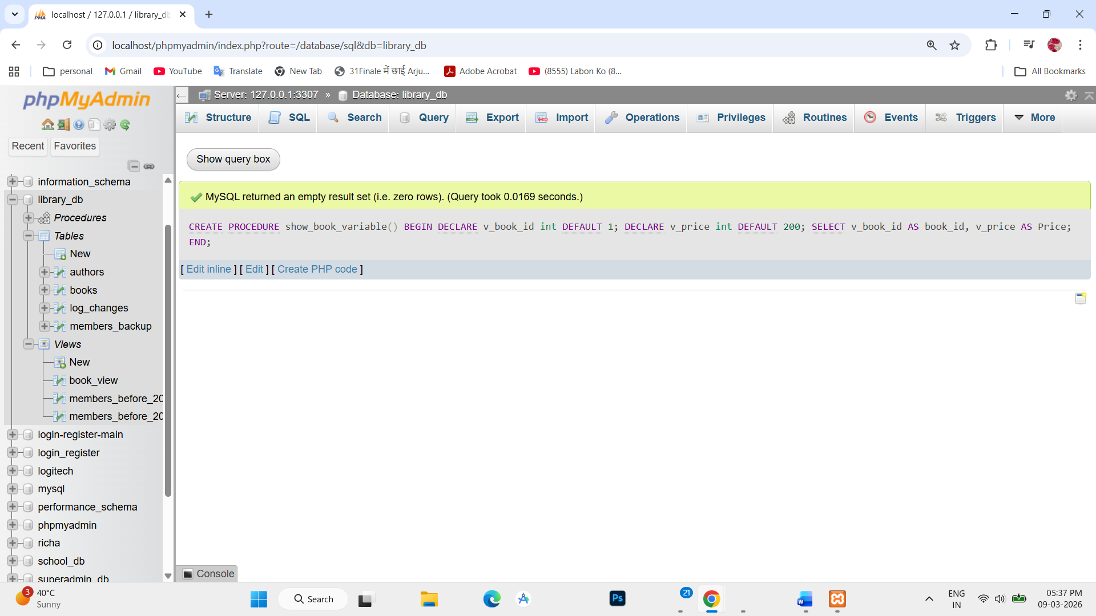

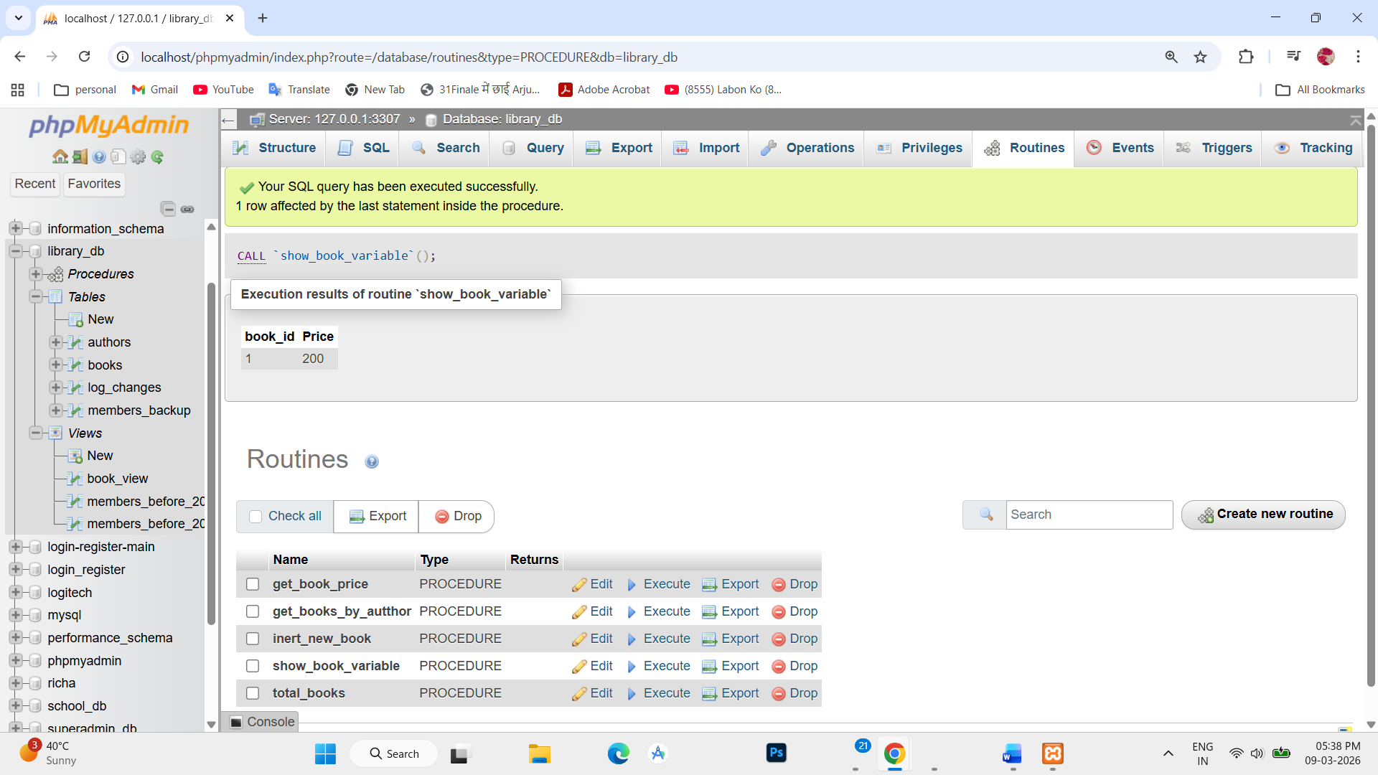

Lab 2.
Write a PL / SQL block using constants and perform arithmetic operations on book price.
Ans.
1. DELIMITER $$

CREATE PROCEDURE calculate_book_price()
BEGIN

DECLARE book1_price DECIMAL(10,2) DEFAULT 500;
DECLARE book2_price DECIMAL(10,2) DEFAULT 300;
DECLARE discount_amount DECIMAL(10,2) DEFAULT 50;

DECLARE total_price DECIMAL(10,2);
DECLARE discounted_price DECIMAL(10,2);
SET total_price = book1_price + book2_price;
SET discounted_price = total_price - discount_amount;
SELECT CONCAT('Total Price of Books: ', total_price) AS TotalPrice,
CONCAT('Price after Discount: ', discounted_price) AS PriceAfterDiscount;
END$$
DELIMETER ;

